Path Planning with Fisba

Meaning of color:

Blue: the terminology may need to be unified with other parts of manual

Red: May need to rework due to different reasons or material missing

Table of Contents

Introduction 2

Objective 2

Version 2

Step by step user guide 3

Preliminary works 3

Lens suitable 3

Add reference arrow on edge 3

Additional modules required for software 3

Measurement phase 4

Perform interferometer measurement 4

Record the coordinates of reference arrow 4

Export result in .xyz format 4

Positioning phase 4

Start the path planning software 4

Choose the data file 5

Input the reference arrow position 6

Place the lens in MJP working chamber 6

Turn on the pump 6

Impact the jet to the reference arrow 6

Input the current nozzle head position to software 6

Input 2 more coordinates of point on the edge the lens 6

Removal determination phase 7

Essential functions 7

Adjust resize factor 7

Adjust removal coefficient 9

Optional functions 9

Circular mask 9

Cut off value 10

Isolate the path 11

Path generation phase 13

Generate 13

Generate even path 15

Additional information 15

Table of figures 15

.xyz data format details 16

Other software components 17

Library documentation 17

Profiling 17

FAQ 17

# Introduction

## Objective

The precise path planning system is built for the Magnetorheological Jet Polishing (MJP) project. One of the difficulty of the project is the measurement module (interferometry system) and the fabrication module (MJP system) are separated and with different coordinate system. It is possible to perform high precision polishing of freeform optical element only if the 2 parts integrated correctly. Thus the path planning system is built to tackle such problem. Moreover, it provides a convenience way to perform the feedback loop of highly automated measurement-fabrication process. In long term, this system is not limited to MJP project but it is aimed to be developed to a generalized tool, which can eventually be applied on all kind of measurement-fabrication system.

## Version

This manual refers to the software version v0.1.2.

# Step by step user guide

## Preliminary works

### Lens suitable

Lenses that can be measured by sub-aperture stitching interferometry setup are suitable. For example, includes but not limited to circular flat and freeform elements.

### Add reference arrow on edge

For lenses that are going to be polished by using this system, a reference arrow must be added to its edge. It can be done by using a oil based pen, the finer the better.

(diagram of reference arrow with lens real)

### Additional modules required for software

The key component, the path planning program, is written in python with interpreter version 2.7, 64-bit, run under Window environment. As python is an portable programming language, theoretically, it can run in other platform like Linux and Mac OS.

Additional python modules are required, including,

* matplotlib
* numpy
* sympy
* python image library (abandoned actually)
* xlutils
* win32clipboard

Also the interactive shell ‘IPython’.

These modules can be downloaded legally and easily from internet.

## Measurement phase

### Perform interferometer measurement

Refers to MJP_FISBA_QuickGuild for simple measurement and MJP_SSI300_EQuickGuild for sub-aperture stitching. The measurement steps are the same.

### Record the coordinates of reference arrow

After taking a reliable measurement, do not move the lens. Record the reference arrow position of the lens in term of pixel in interferometer CCD. You may use some widgets like needle, paper strip, small string, etc to help you for this purpose.

[diagram of reference arrow in reality during measurement (with needle)]

[diagram of reference arrow in mshape]

[diagram of reference arrow in mshape] (zoom-in)

In this example, x=?, y=? are recorded as the position of reference arrow.

### Export result in .xyz format

Export the result in ‘.xyz’ format for path planning software to analyze and process. For more details, please read ’.xyz data format details’.

# Positioning phase

### Start the path planning software

To start the software, simply double click gui.py to start it.

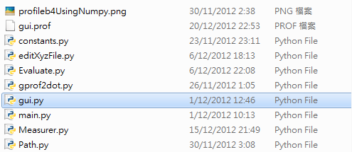

Fig. gui.py in folder

The following graphical user interface will pop up. It will be introduced in detail in the following parts.

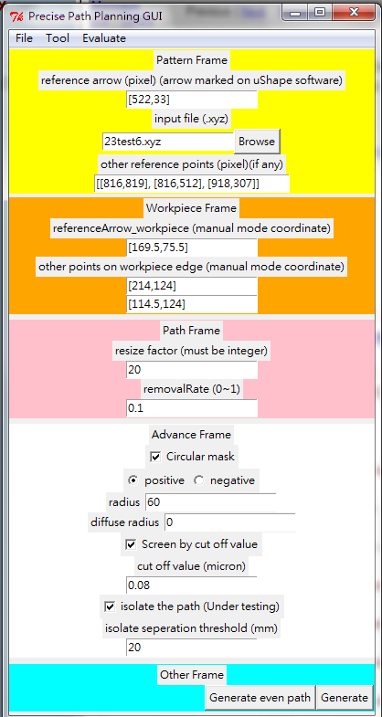

Fig. Path planning software main console

### Choose the data file

Load the .xyz file of interferometry measurement result to the path planning software.

Type the name of the file with full path or choose it with the file browser.

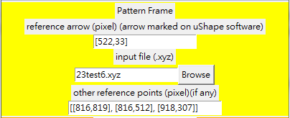

Fig. Pattern frame

### Input the reference arrow position

Type in the reference arrow position recorded before in the format [x-coordinate, y-coordinate]. The square blanket is necessary.

[diagram: x,y coordinate reference arrow on MJP program]

### Place the lens in MJP working chamber

Place it with the reference arrow available to be visualize from outside.

[diagram: lens 24 in chamber]

### Turn on the pump

The following steps aimed to find the exact position and orientation of the lens in MJP machine. You need the jet turned on for this work. Before that, adjust the jet pressure to minimum value to avoid the lens from being damaged by it.

### Impact the jet to the reference arrow

Move the jet so that it can impact to the reference arrow of the lens. You may need multiple trials for this step.

[diagram: jet impacting the reference arrow]

### Input the current nozzle head position to software

Input the position of nozzle head in **MJP machine coordinate**.

### Input 2 more coordinates of point on the edge the lens

Repeat the method of impacting the jet to reference arrow to find 2 more points on the edge of the lens and input them to the path planning software.

## Removal determination phase

The following steps relate to removal rate and part of the path.

## Essential functions

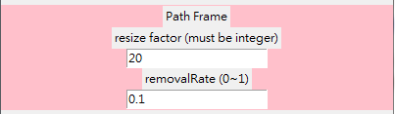

Fig. Path frame

The following functions control the removal of the planned path. Since MJP machine currently do not have real time control on jet pressure, the variation of removal according to the profile deviation is controlled by the travelling velocity of the jet from point to point. The removal function of a point currently used is

Eqn. Function of jet travelling velocity.

So the point with higher profile deviation will have the jet travels slower on it, which means it stays longer hence provide more removal.

### Adjust resize factor

It controls the number of data points of the generated path. The larger it is, the less points will have in the generated path. It must be integer.

Here is the algorithm:

Assume the following table is the data map of the full data-sized path. The ‘X’ means there is a value at that position, while the rest is ‘no data’.

For each data point, if its x or y coordinate is divisible by resize factor, it will remain in the resultant path, otherwise it will be removed.

|  |  |  |  |  |  |  |  |  |  |  |
| --- | --- | --- | --- | --- | --- | --- | --- | --- | --- | --- |
|  | 0 | 1 | 2 | 3 | 4 | 5 | 6 | 7 | 8 | 9 |
| 0 |  |  | X | X | X | X | X | X |  |  |
| 1 |  | X | X | X | X | X | X | X | X |  |
| 2 |  | X | X | X | X | X | X | X | X |  |
| 3 | X | X | X | X | X | X | X | X | X | X |
| 4 | X | X | X | X | X | X | X | X | X | X |
| 5 |  | X | X | X | X | X | X | X | X |  |
| 6 |  | X | X | X | X | X | X | X | X |  |
| 7 |  |  | X | X | X | X | X | X |  |  |

If the resize factor is 2, the resultant data points is,

|  |  |  |  |  |  |  |  |  |  |  |
| --- | --- | --- | --- | --- | --- | --- | --- | --- | --- | --- |
|  | 0 | 1 | 2 | 3 | 4 | 5 | 6 | 7 | 8 | 9 |
| 0 |  |  | X | X | X | X | X | X |  |  |
| 1 |  |  | X |  | X |  | X |  | X |  |
| 2 |  | X | X | X | X | X | X | X | X |  |
| 3 | X |  | X |  | X |  | X |  | X |  |
| 4 | X | X | X | X | X | X | X | X | X | X |
| 5 |  |  | X |  | X |  | X |  | X |  |
| 6 |  | X | X | X | X | X | X | X | X |  |
| 7 |  |  | X |  | X |  | X |  |  |  |

If the resize factor is 3, the resultant data points is,

|  |  |  |  |  |  |  |  |  |  |  |
| --- | --- | --- | --- | --- | --- | --- | --- | --- | --- | --- |
|  | 0 | 1 | 2 | 3 | 4 | 5 | 6 | 7 | 8 | 9 |
| 0 |  |  | X | X | X | X | X | X |  |  |
| 1 |  |  |  | X |  |  | X |  |  |  |
| 2 |  |  |  | X |  |  | X |  |  |  |
| 3 | X | X | X | X | X | X | X | X | X | X |
| 4 | X |  |  | X |  |  | X |  |  | X |
| 5 |  |  |  | X |  |  | X |  |  |  |
| 6 |  | X | X | X | X | X | X | X | X |  |
| 7 |  |  |  | X |  |  | X |  |  |  |

### Adjust removal coefficient

It controls the stay time for each point of the generated path. The range is 0-1 (exclusive). The smaller the coefficient, the smaller the travelling velocity of jet, and hence the more removal.

### Optional functions

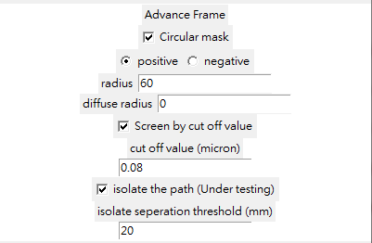

Fig. Advance frame

The following will only in use when the checkbox associate to them is ticked.

### Circular mask

Only work on part of the lens, instead of whole. The mask centre currently can only specified by ‘other reference points’ in Pattern Frame (the yellow region). Input coordinates of 3 points (in pixel) and it will specify a centre of a virtual circle constrained by them. The reason of such practice is in most cases, the mask is determined when observing interferometer measurement.

Other parameters required,

*Positive/Negative: for positive, the lens part within the mask will be polished, and vise versa.*

*Radius: Radius of mask (unit: mm)*

*Diffuse radius: A diffuse radius in addition to ordinary radius (unit: mm)*

Usage of diffuse radius: Sometimes we do not want the edge of polishing region to be too sharp. Therefore, we may add a buffer region with smaller removal (higher jet travelling velocity) by using this parameter. The function jet travelling velocity of a specific point the diffuse region is

Eqn. Jet travelling velocity in circular mask diffuse region

The $original jet travelling velocity$ may refer to ‘Eqn. 1 Function of jet travelling velocity.’ on page 7.

For example, if the original radius is 10mm, the diffuse radius is 5mm. The total mask radius will be 15mm.

Here is an example of circular mask. The radius set is 10mm

Fig. Left: measured pattern. Right.: Generated path after using circular mask

### Cut off value

Only polish the part of lens with the profile deviation larger than the value specified.

*Cut off value: The threshold (micrometer)*

You may choose it during interferometer measurement. Moreover, it is advised to be used with ‘isolate the path’ for correct polishing path.

The following example uses a cut off value 0.04 micrometer, which means the parts below 0.038 micrometer will not be included in the polishing path.

Fig. Left: original measured pattern. Right: The generated path with using cut off value

### Isolate the path

The key function for planning the path when the parts to be polished scatter around the lens. It re-schedules the path in order to avoid polishing those unwanted parts.

*Isolate separation threshold: if the separation of consecutive data points is larger than this value, they will be isolated the path into different regions*

The path will also jump from region to region with maximum velocity allowed to avoid polishing the unwanted parts. (10mm/s for MJP machine)

Here is the comparison.

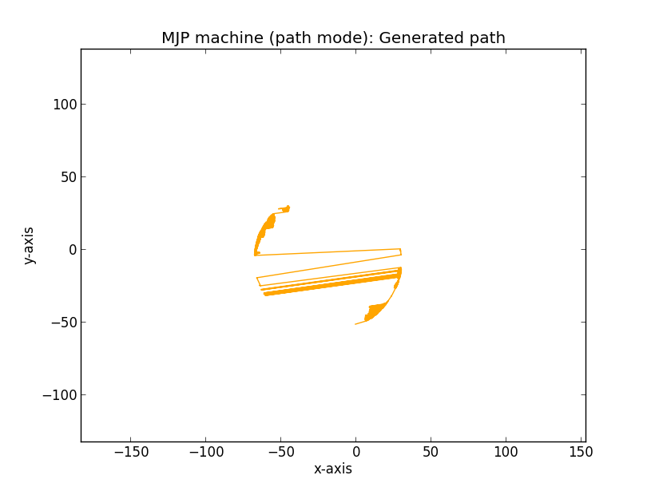

Fig. 8 Path without using isolate.

The path with isolate used. The straight lines cross the mirror actually moves with 10mm/s in MJP machine in this case.

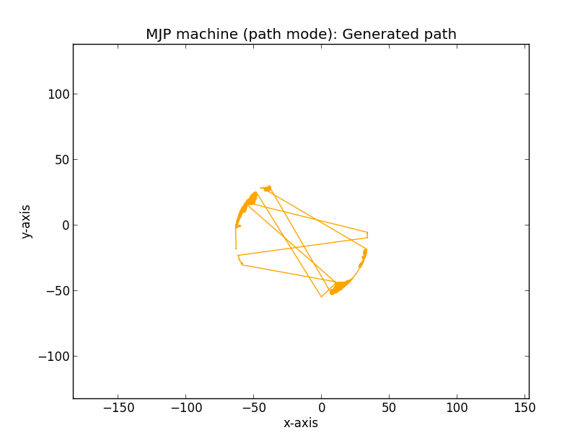

Fig. 9 Path with using isolate.

## Path generation phase

gui other frame.png

Fig. Other frame

### Generate

Press generate button then it will start generating a path. A text file which is the path will be generated. The name is structured as follow,

*[input file name]_[total polishing time (s)].txt*

For example, the file

*23test6_5524s.txt*

is generated by the input file *23test6.xyz*, and the total polishing time will be 5524 seconds (1 hour 32 minutes 4 seconds).

The file can directly read by MJP machine software for polishing.

2 plots will pop out when the generation is finished. They are

The plot of actually polishing part in MJP machine

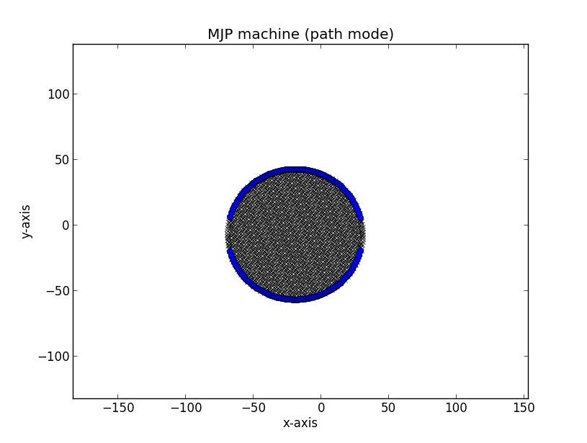

Fig. The part polishes and lens position.

The blue arc shows the edge of the current position of lens in MJP machine.

The black section shows the actually part the polishes.

The actual path in MJP machine

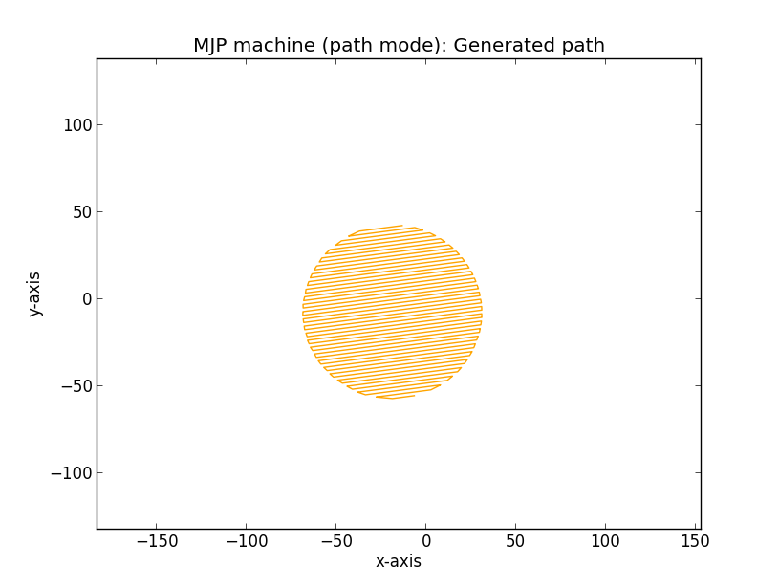

Fig. The actually generated path.

### Generate even path

This function mainly used for testing purpose. It generates a path with fixed travelling velocity of jet, which is equal to the removal coefficient in mm/s. The rest is the same as ‘Generate’. In other words, the travelling velocity of jet **does not** vary according to profile variation.

# Additional information

## Table of figures

Fig. 1 gui.py in folder 4

Fig. 2 Path planning software main console 5

Fig. 3 Pattern frame 5

Fig. 4 Path frame 7

Fig. 5 Advance frame 8

Fig. 6 Left: original measured pattern. Right: The generated path with using cut off value 9

Fig. 7 Other frame 9

Fig. 8 The part polishes and lens position. 10

Fig. 9 The actually generated path. 11

## .xyz data format details

The ‘.xyz’ format was originated by Zygo company. It is written in plain text. You may open it with any simple text editor (e.g. notepad, vim, MS Word, etc.). The first few lines are file header which are not important in our case. The interferometer measurement data starts and ends with a row with only ‘#’. The rows in between are the data.

Here is an example,

**The header:**

*Zygo XYZ Data File - Format 1*

*0 0 0 0 ""*

*0 0 0 0 1 255*

*0 0 1020 1024*

*"arrow = [471,70]"*

*"18"*

*" "*

*0 0.500000 6.328000e-007 0.000000 1.000000 0.000000 1.040908e-004 0*

*1020 1024 0 0 0 0 ""無ens DCI2"*

*0 1 0 0 0 0 1.000000 0 0 0*

*0 1 1 0 0 0 0 0 1*

*1 ""*

*1.000000 0.000000e+000*

**The data:**

*#*

*0 0 No Data*

*1 0 No Data*

*2 0 No Data*

*……*

*567 619 -0.025*

*568 619 -0.020*

*569 619 -0.017*

*……*

*1017 1023 No Data*

*1018 1023 No Data*

*1019 1023 No Data*

*#*

For each row, it represents a data point (pixel), with value separated by a tab, (or ‘\t’ in programming representation), which

Value 1: x-coordinate (Unit: pixel)

Value 2: y-coordinate (Unit: pixel)

Value 3: profile deviation (Unit: micrometer). If it is ‘No Data’, it means there was no data detected during measurement.

The number of rows is equal to the number of pixels of measurement. If no measurement mask was used, it equals to the number of pixels of CCD of interferometer.

## Other software components

## Library documentation

## Profiling

# FAQ